Software Requirement Specification

NHOM6-SRS-001

Version 1.0

**Revision History**

| Date | Version | Description | Author | Revised by |
| --- | --- | --- | --- | --- |
| 20/03/2018 | 1.0 | First version |  |  |
|  |  |  |  |  |
|  |  |  |  |  |
|  |  |  |  |  |
|  |  |  |  |  |

Table of Contents

**1.** **Introduction** 5

**1.1** **Overview** 5

**1.2** **Scope** 5

**2.** **Functional Requirements** 6

**2.1** **Feature/Component #1:** **Login page** 6

2.1.1 User Interfaces 6

2.1.2 Functional Requirements 6

**2.2** **Feature/Component #2:** **Registration page** 7

2.2.1 User Interfaces 7

2.2.2 Functional Requirements 8

**2.3** **Feature/Component #3:Home page**  9

2.3.1 User Interfaces 9

2.3.2 Functional Requirements 9

**2.4** **Feature/Component #4:News page** 13

2.4.1 User Interfaces 13

2.4.2 Functional Requirements 13

**2.5** **Feature/Component #5: Tour page** 15

2.5.1 User Interfaces 15

2.5.2 Functional Requirements 15

**2.6** **Feature/Component #6:** **Personal page** 16

2.6.1 User Interfaces 16

2.6.2 Functional Requirements 17

**2.7** **Feature/Component #7:** **Update information** 19

2.7.1 User Interfaces 19

2.7.2 Functional Requirements 19

**2.8** **Feature/Component #8:Password change page** 20

2.8.1 User Interfaces 20

2.8.2 Functional Requirements 20

**2.9** **Feature/Component #9:** **List of booked tours** 22

2.9.1 User Interfaces 22

2.9.2 Functional Requirements 22

**2.10** **Feature/Component #10:** **travel company** 23

2.10.1 User Interfaces 23

2.10.2 Functional Requirements 24

**2.11** **Feature/Component #11:** **Update travel agency information** 26

2.11.1 User Interfaces 26

2.11.2 Functional Requirements 26

**2.12** **Feature/Component #12: Add tour** 28

2.12.1 User Interfaces 28

2.12.2 Functional Requirements 28

**2.13** **Feature/Component #13:Delete tour** 30

2.13.1 User Interfaces 30

2.13.2 Functional Requirements 30

**2.14** **Feature/Component #14: Edit content tour** 31

2.14.1 User Interfaces 31

2.14.2 Functional Requirements 31

**2.15** **Feature/Component #15:** **List of tour companies** 32

2.15.1 User Interfaces 32

2.15.2 Functional Requirements 32

**2.16** **Feature/Component #16:** **Tour guests booked** 33

2.16.1 User Interfaces 33

2.16.2 Functional Requirements 33

# **Introduction**

## **Overview**

This software supports users to view beautiful landscapes in two regions (South, Central), and they can also post on their own posts.

## **Scope**

Demo version

Demo version is for display purpose only, not link to Database, not link to affiliated sites

Android OS: Android: OS 4.0.X to 6.0.X

* Android test devices: Xiaomi MI4, Nexus S, Samsung Galaxy S2

Android screen resolutions: 480x800, 720x1280

Support screen orientation in landscape mode only

# **Functional Requirements**

## **Feature/Component #1: login page**

### User Interfaces

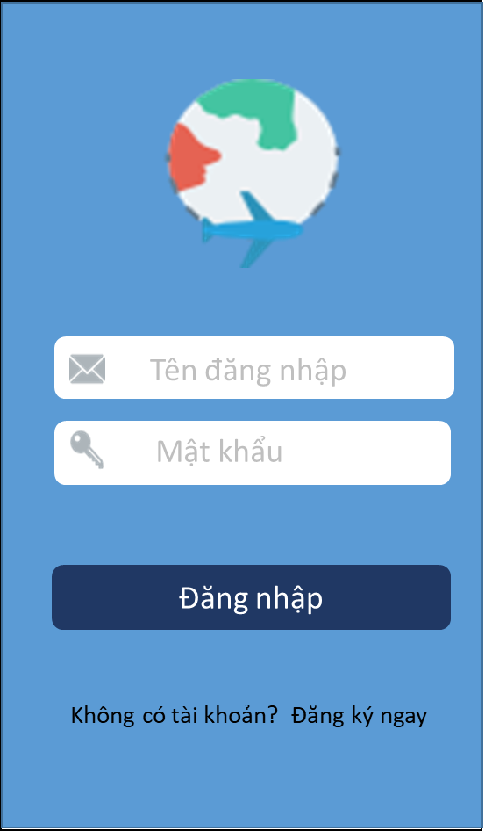

*Image1:* login page

### Functional Requirements

|  |  |  |  |
| --- | --- | --- | --- |
| **Item** | **Description** | **Action** | **Response** |
| login page | Include:   * 1 Button * 2 Text Box * Text View * 1 Logo | N/A | N/A |
| Button “login” | Log in successfully if correct account information | Click | Logged in successfully,  Switch to homepage |
| Logo | Contains the logo of the application | N/A | N/A |
| Text Box “User name  ” | Allows the user to enter a login name | N/A | N/A |
| Text Box “Password” | enter password | N/A | N/A |
| Text View “Register now” | For customers who register without an account | Click | Go to the Subscriptions page |

## **Feature/Component #2:** **Registration page**

### User Interfaces

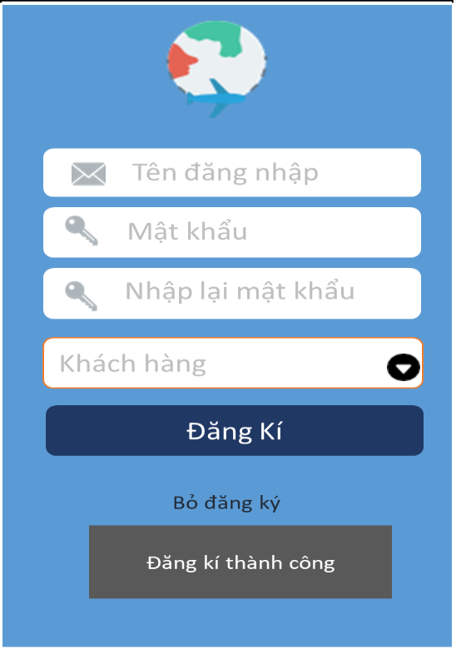

*Image2: Registration page*

### Functional Requirements

|  |  |  |  |
| --- | --- | --- | --- |
| **Name** | **Description** | **Action** | **Response** |
| Registration page | Include:   * 1 Button * 4 Textbox * 1 Text View * 1 icon | N/A | N/A |
| Text Box “Enter account name” | Enter account name | N/A | N/A |
| Text box” Enter password” | Enter password | N/A | N/A |
| Text box “Retype your password again “ | Retype your password again | N/A | N/A |
| Text box “Customers / Travel Company “ | Allows users to choose between "Customer" and "Travel Company". | Click | Select "Customer" when registering.  Select " Travel Company " if allowedallowed |
| Button “Registration” | Registration is successful if the correct information is registered | Click | When successful registration will be announced "Successful registration" |
| Text View “Unsubscribe “ | If you do not want to continue signing up for an account | Click | Go back to the previous page |
| Icon | Allows users to choose between "Customer" and "Travel Company". | Click | Select "Customer" when registering.  Select " Travel Company " if allowedallowed |

## **Feature/Component #3: Home page**

### User Interfaces

*Image3 :Home page*

### Functional Requirements

|  |  |  |  |
| --- | --- | --- | --- |
| **Name** | **Description** | **Action** | **Response** |
| Home page | Include:   * Maps * List view * 1 Text Box * 4 icon | N/A | N/A |
| Maps | Contains the location on the map that the customer selects | N/A | N/A |
| ListView | Contains maps, and corresponding icons | N/A | N/A |
| Text box “Choose province “ | Enter the province that you want to visit. | N/A | Read the corresponding location data |
| “ Home page“ | Search for places to look on the map. | Click | Read data for search locations.. |
| “News page “ | post new posts and see other people's posts | Click | Go to "News Page" |
| “ Tour page “ | Contains list of DL tours | Click | Go to the "Tour DL “ |
| “  account” | Contains account information page | Click | Go to the " account “ |
| Icon | Contains all the provinces | Click | Select a province wishes |
| Icon | Contains placements around your travel destination | Click | Read all travel data around your chosen location |
| Icon | Display your current location (if not entered in the text box select the province) | Click | Read your current location data |
| Icon | Return to previous page | Click | Go to the previous page |

**2.2.1 Detail page and book tour**

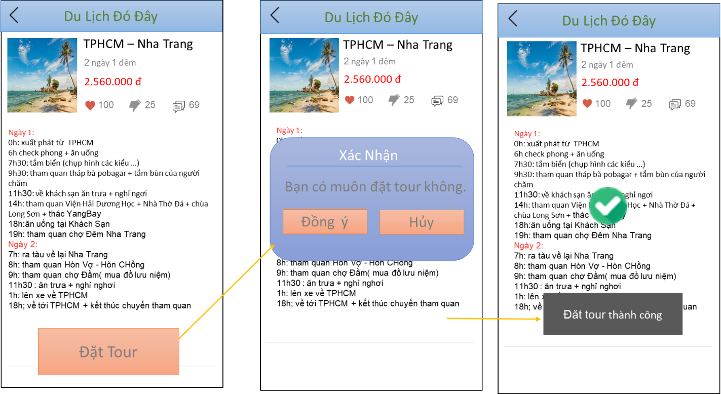

*Image4 : Detail page and book tour*

### Functional Requirements

|  |  |  |  |
| --- | --- | --- | --- |
| Detail page and book tour | Include:   * 3 Text View * 1 Image view * 1 List view * 1 Button * 1 Icon | N/A | N/A |
| List View | Display name, price, detailed content ... of the location you choose | N/A | N/A |
| Image View | Contains an image of the location you selected on the map | N/A | N/A |
| Text View “ Tour name “ | Contains the name of the tour you choose | N/A | N/A |
| Text View “ Time ” | Displays the duration of the tour | N/A | N/A |
| Text View “Price “ | Displays the price of the tour | N/A | N/A |
| Icon | Return to previous page | Click | Go to previous page |
| Button “Book tour” | Allows users to order selected tours on the map | Click | The application will confirm whether you want to make a tour.  If Agree will report "Successful Tour Book"  Otherwise go back to the previous page |
| Button “Agree” | If agreed to make a tour | Click | Make a successful tour |
| Button “Cancel” | If you do not want to book tours | Click | Go to previous page |
| Icon | if “Like” | Click | Change the icon color to red and  Displays its "Like" number |
| Icon | if “Dislike" | Click | Change the icon color to black and  Displays the number of "dislikes" of it. |
| Icon | if“ comment “ | Click | Go to its comment page. |

## **Feature/Component #4: News page**

### User Interfaces

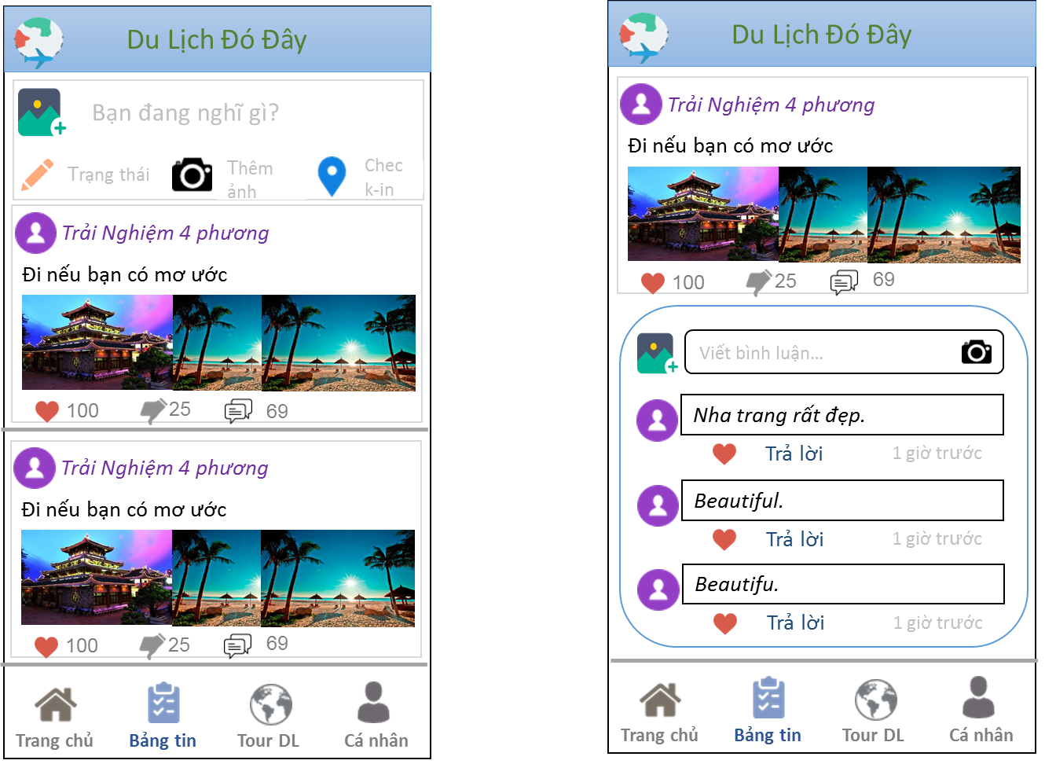

*Image5: Home page*

### Functional Requirements

|  |  |  |  |
| --- | --- | --- | --- |
| Item | Description | Action | Response |
| *Home page* | Include:   * Image view * 2 Text View * List view * 1 action Bar * 6 Icon | N/A | N/A |
| Image View | Contains images of other clients posted | Click | Read detailed information of that article |
| Text View | Display names of other customers | N/A | N/A |
| Text View | Show other people's posts | N/A | N/A |
| List View | Allows users to update status, images, and view message boards of other customers | N/A | N/A |
| Action Bar | Display the name of the tour operator | N/A | N/A |
| Text Box | Allows users to write their status | N/A | N/A |
| Icon | Allows the user to choose the image posted on the message board | Click | Show the selected image in the post |
| Icon | Allows the user to check-in the desired location | Click | Shows where users want to check-in |
| Icon | Allows the poster's emotions | Click | Show the poster's emotions. |
| Icon | if “Like” | Click | Change the icon color to red and  Displays its "Like" number |
| Icon | if “Dislike" | Click | Change the icon color to black and  Displays the number of "dislikes" of it. |
| Icon | if“ comment “ | Click | Go to its comment page. |

## **Feature/Component #5: Tour page**

### User Interfaces

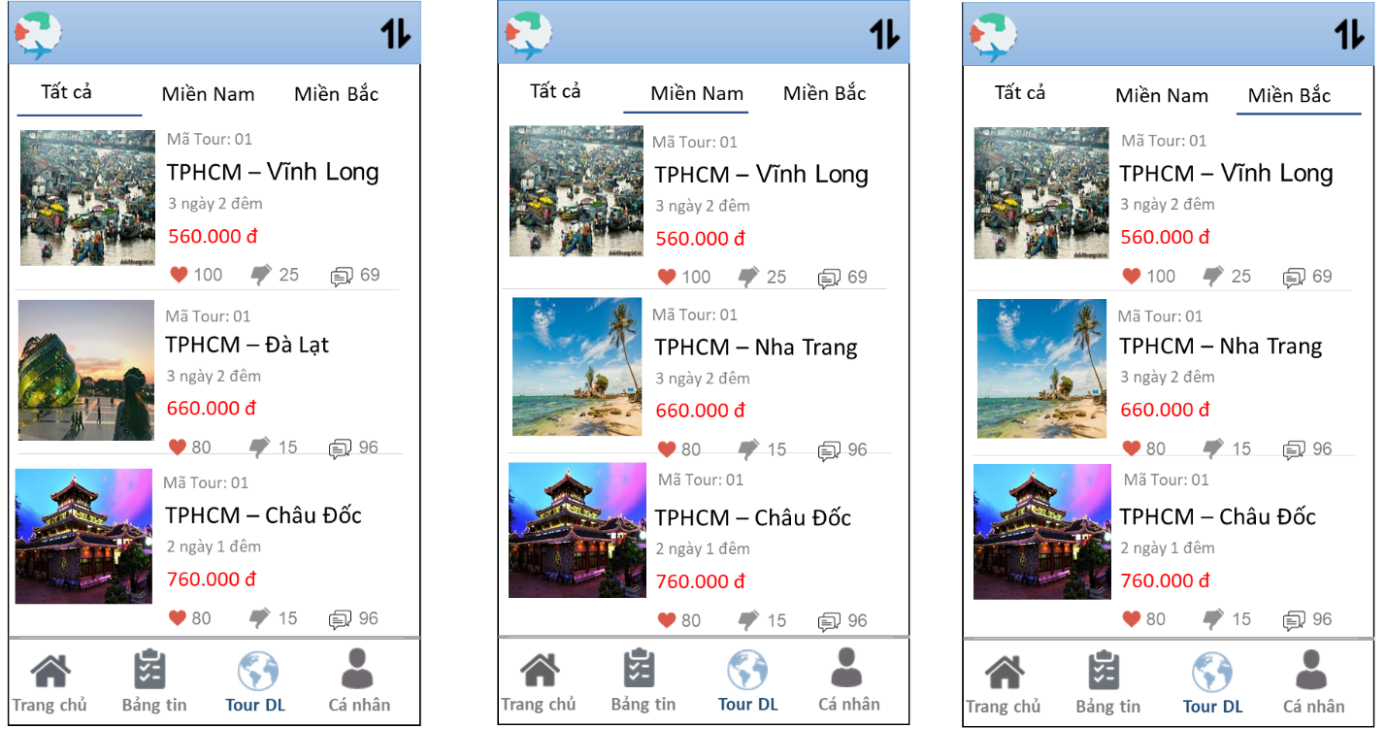

*Image6: Tour page*

### Functional Requirements

|  |  |  |  |
| --- | --- | --- | --- |
| **Name** | **Description** | **Action** | **Response** |
| Tour page | Include:   * 3 Tab View * Image view * 4 Text View * List view * 1 icon | N/A | N/A |
| ListView | Contains tour code, image, price, time, and icon respectively. | N/A | N/A |
| Image view | Contains image of the tour | Click | Switch to the detail screen of the tour. |
| Text View “Tour code “ | Show tour code | N/A | N/A |
| Text View “ Tour name “ | Show tour name | Click | Go to the detailed screen of the tour |
| Text View “ Time “ | Displays the time of the tour | N/A | N/A |
| Text View “Price” | Show Price | N/A | N/A |
| Tab View “All” | Contains all existing tour listings | Click | Read data "all" tour list |
| Tab View “South” | Contains a list of tours in "South" | Click | Read tour list data of "South" |
| Tab View “Northern” | Contains a list of tours in " Northern " | Click | Read tour list data of " Northern " |
| Icon | Organize tour Increase / decrease by price | Click | Read articles that are sorted by price increase / decrease. |

## **Feature/Component #6: Account**

### User Interfaces

*Image7: Account*

### Functional Requirements

|  |  |  |  |
| --- | --- | --- | --- |
| Item | Description | Action | Response |
| Account | Include:   * 4 icon * 4 Text box | N/A | N/A |
| Image view | Show icons corresponding to each function | N/A | N/A |
| Text box “account information” | The name of the icon | Click | Go to the account information screen |
| Text box “change your password” | The name of the icon | Click | Go to change your password |
| Text box “ tour listing booked ” | The name of the icon | Click | Go to tour listing booked |
| Text box “log out” | The name of the icon | Click | Read the data, log out successfully, and return to the login page |
| Icon | Icon for '' account information '' | N/A | N/A |
| Icon | Icon for ‘’ change your password ‘’ | N/A | N/A |
| Icon | Icon for ‘’ tour listing booked ‘’’ | N/A | N/A |
| Icon | Icon for ‘’ log out‘’ | N/A | N/A |
|  |  |  |  |
| account information page | Include:   * Image view(chứa những hình ảnh hoăc icom tương ứng) * 5 textBox * 7 icon | N/A | N/A |
| TextBox “customer name” | Show customer name | N/A | N/A |
| TextBox “birthday” | Show date of birthday | N/A | N/A |
| TextBox ”Male/Female  ” | Show Male/Female | N/A | N/A |
| TextBox “phone number” | Show phone number | N/A | N/A |
| TextBox “Address” | Show Address | N/A | N/A |
| Icon | Customer name | N/A | N/A |
| Icon | Date of birthday | N/A | N/A |
| Icon | Male/Female | N/A | N/A |
| Icon | Phone number | N/A | N/A |
| Icon | Address | N/A | N/A |
| Icon | Change of personal information | click | Go to the personal information change screen |
| Icon | Back to the previous page | Click | Go to the previous page |

## **Feature/Component #7: Change of personal information**

### User Interfaces

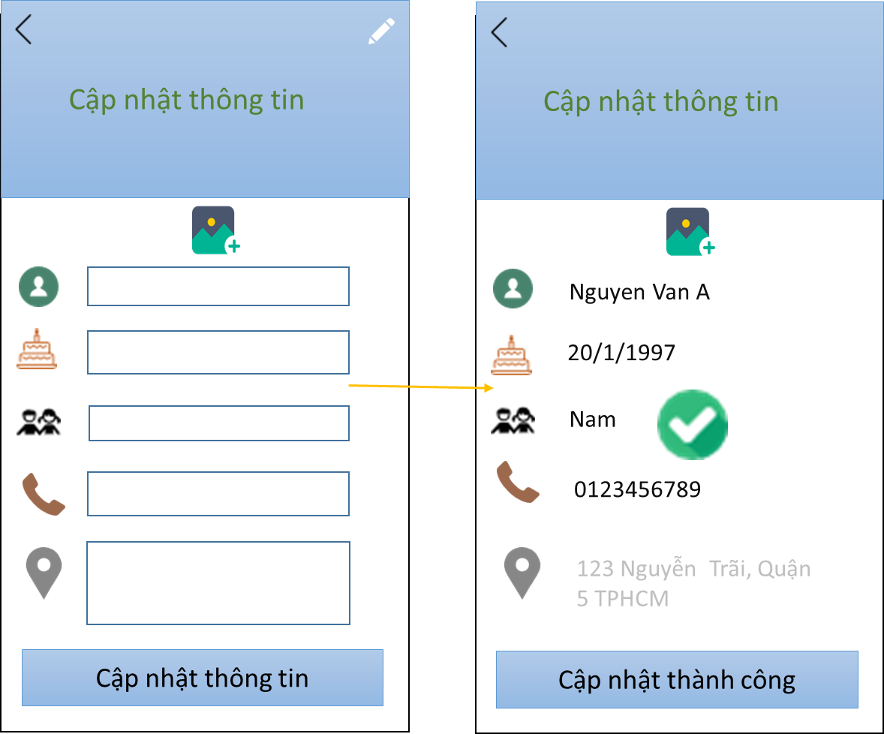

*Image8:* Change of personal information

### Functional Requirements

|  |  |  |  |
| --- | --- | --- | --- |
| **Name** | **Description** | **Action** | **Response** |
| Change of personal information | Include:   * 5 edit text * Icon | N/A | N/A |
| Edit text “Customer name” | Enter customer name | N/A | N/A |
| Edit text “birthday” | Enter birthday | N/A | N/A |
| Edit text “Male/Female” | Enter Male/Female | N/A | N/A |
| TextBox “Phone number” | Enter phone number | N/A | N/A |
| Edit text “Address" | Enter the address  (User can hide or show private address) | N/A | N/A |
| Button “Update successful " | save change information | Click | Read the updated data, and the current Update Message is successful. |
| Icon | Back to the previous page | Click | Go to the previous page |
| Update successful | Notifications and icons            after a successful update | N/A | N/A |

## **Feature/Component #8: Change Password page**

### User Interfaces

*Image9: Change Password page*

### Functional Requirements

|  |  |  |  |
| --- | --- | --- | --- |
| Item | Description | Action | Response |
| Change Password page | Include :   * 3 edit text * 2 Button * icon | N/A | N/A |
| Edit text “ old password ” | Enter old password | N/A | N/A |
| Edit text “ A new password" | Enter A new password" | N/A | N/A |
| Edit text “ Confirm new password “ | Show Confirm new password | N/A | N/A |
| Button “ Agree ” | When the user completes the validation information | Click | Read the new password data and now the message changes successfully. |
| Button “ Hủy “ | If user k intends to change the password | Click | Go to the previous page |
| Icon | Go to the previous page | Click | Go to the previous page |
| Update successful | Notifications and icons            after a successful update | N/A | N/A |

## **Feature/Component #9: Tour Book List page**

### User Interfaces

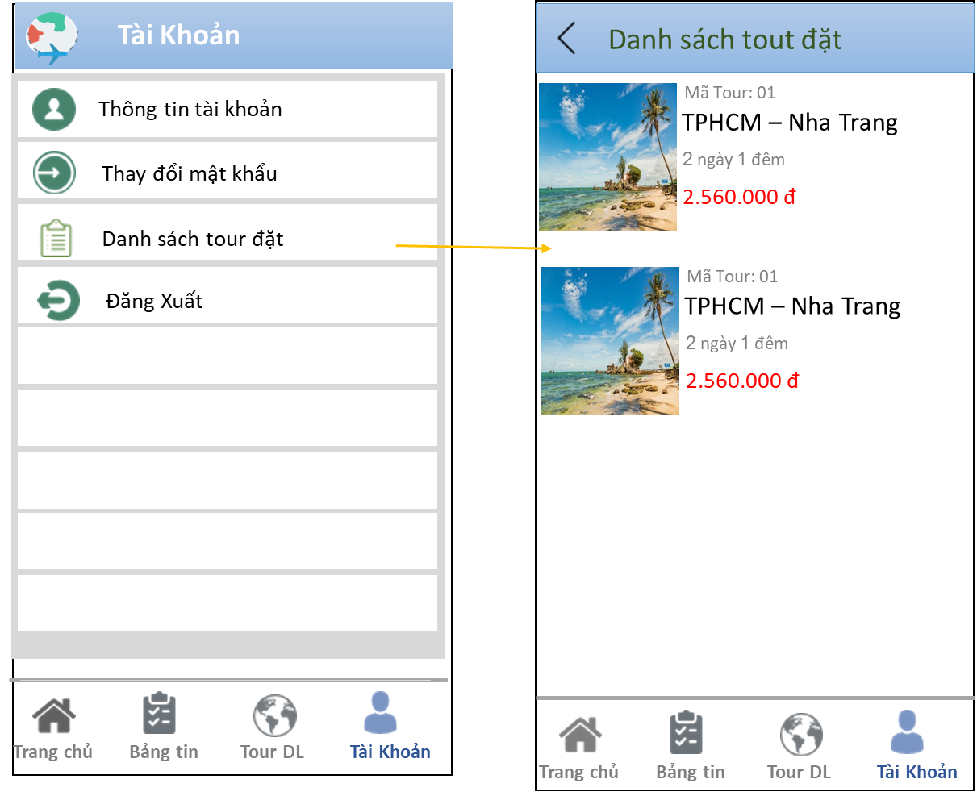

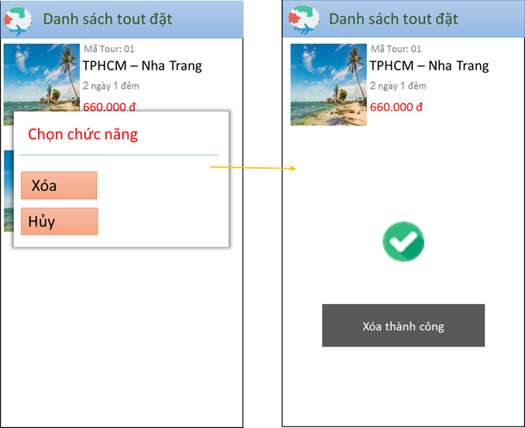

*Image10:* *Tour Book List (In the tour list, users can delete the booked tour)*Functional Requirements

|  |  |  |  |
| --- | --- | --- | --- |
| **Name** | **Description** | **Action** | **Response** |
| *Tour Book List page* | Include:   * Image view * 4 text view * Icon * List view * 2 button | N/A | N/A |
| List view | Show selected tours (details, price, tour code ...) | N/A | N/A |
| Text View “ Tour code “ | Show Tour code | N/A | N/A |
| Text View “ Tour name “ | Show Tour name | N/A | N/A |
| Text View “ Time “ | Show tour time | N/A | N/A |
| Text View “price  “ | Show price tour | N/A | N/A |
| Image View | When you want to delete tour selected | Hold | Confirm to delete the tour or not  If you press "Delete"  If never, will press "Cancel" |
| Button “Delete” | If the user delete tour | Click | Delete the successful tour and return to the selected tour site |
| Button “Cancel” | If the customer does not want to delete the tour | Click | Go to tour listing page |
| icon | Go to tour listing page | click | Go to tour listing page |

## **Feature/Component #10: Travel agent**

### User Interfaces

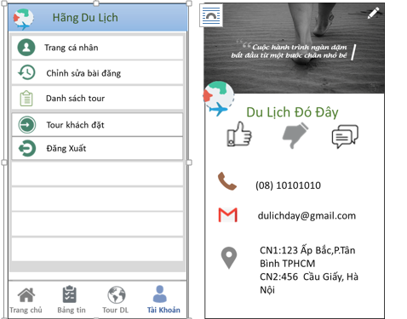

*Image11: Travel agent*

### Functional Requirements

|  |  |  |  |
| --- | --- | --- | --- |
| Item | Description | Action | Response |
| Travel agent | Include :   * 5 danh mục * 4 button | N/A | N/A |
| Personal page | Allows viewing and changing personal information of the travel agency | click | Switch to the Personnel Update page and change the information (if applicable). |
| Edit post | Allows the Travel Company to add, delete or edit tours | click | Go to edit tour page |
| Tour list | Allows the Travel Company to view its current tours. | Click | Go to the tour listing page of the tour |
| Tour have booked | Allows the tour operator to view the tours that the customer has booked | click | Allowing the tour operator to view the tours that the customer has booked |
| Log out | Log out of your account, back to the login screen | click | Log out of your account, back to the login page. |
| Home page | Go to Home page | Click | Go to Home page |
| Bảng tin | Go to news page | Click | Go to news page |
| Tour page | Go to Tour page | click | Go to Tour page |
| Account | If you are a customer, go to the customer's account page  If you are a travel agency, you will go to the account page of the Travel Company | Click | Go to the account page corresponding to the account (Customer / Travel Company). |
|  |  |  |  |
| personal page | Bao gồm :   * 7 icon * 3 text view | N/A | N/A |
| Icon | Used to change personal page information | Click | Go to the information change screen |
| Icon | If “ Like” | Click | In bold and  Show likes |
| Icon | If “ Dislike” | Click | In bold and  Show the number of dislikes |
| Icon | If “ comment “ | Click | Go to the comment page |
| Phone number | Show phone number | N/A | N/A |
| gmail | Show gmail | N/A | N/A |
| địa chỉ | Show address | N/A | N/A |

## **Feature/Component #11: update tour information company**

### User Interfaces

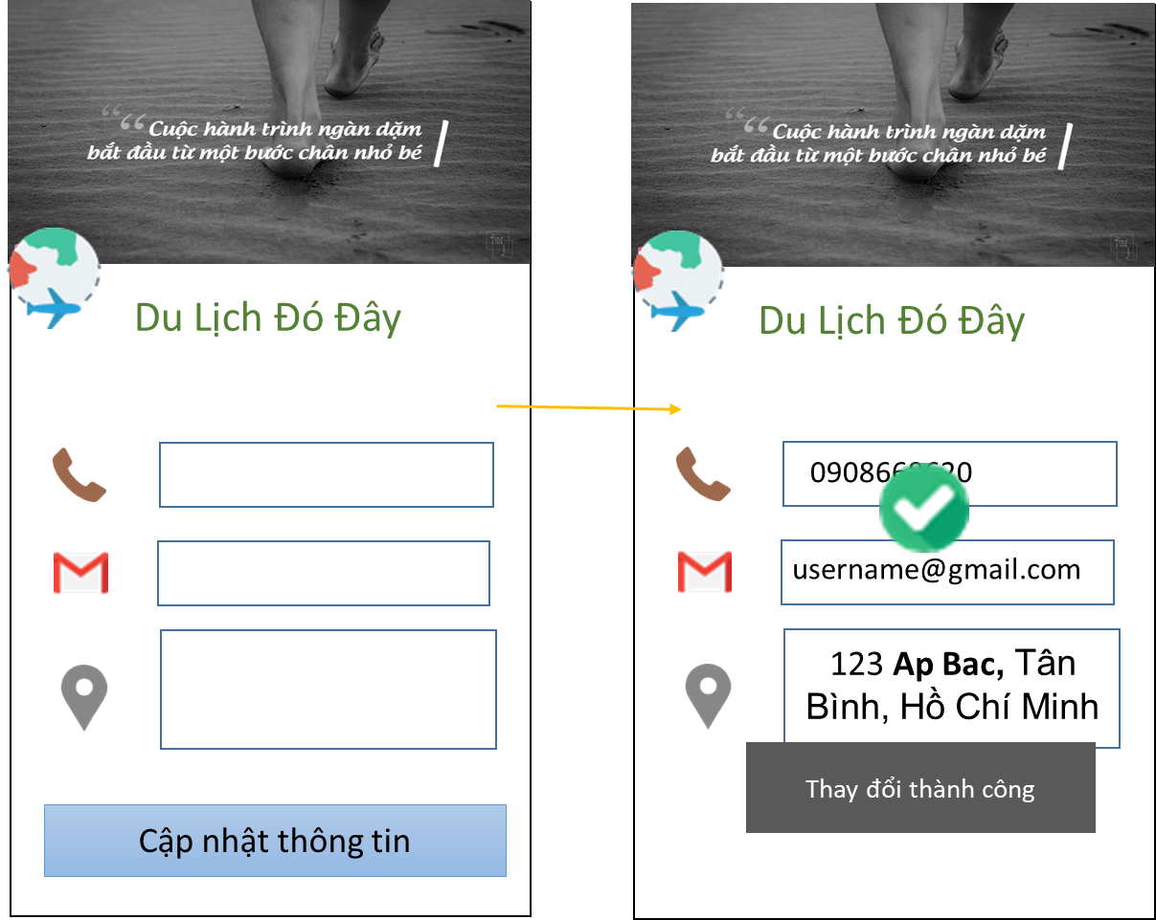

*Image13: update tour information company*

### Functional Requirements

|  |  |  |  |
| --- | --- | --- | --- |
| Item | Description | Action | Response |
| update tour information company | Include :   * List view * 3 Text box * 1 Button * 1 action bar | N/A | N/A |
| Action bar | Display company slogan | N/A | N/A |
| Text box “Phone number ” | Enter phone number | N/A | N/A |
| Text box “gmail” | Enter gmail | N/A | N/A |
| Text box “address” | Enter address | N/A | N/A |
| Button “ update information ” | Would you like to update the information | click | Successful update notification. And read the updated data |
| successful change | Notifications and icons            after a successful change | N/A | N/A |

## **Feature/Component #12: Add tour**

### User Interfaces

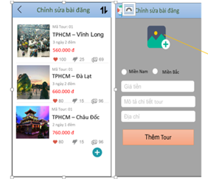

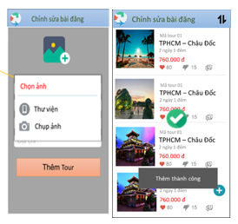

*Image14: :* add tour in edit page

### Functional Requirements

|  |  |  |  |
| --- | --- | --- | --- |
| Item | Description | Action | Response |
| add tour in edit page | Include :   * 1 list view * 3 icon | N/A | N/A |
| List view | Show tour pictures, tour code, price, time corresponding | N/A | N/A |
| Icon | Organize tours at a reduced or incremental price to facilitate tour editing (Add, delete edit) | Click | Display results sorted by decreasing or increasing price. |
| Icon | Want to add a new tour | Click | Switch to the new article page |
| Icon | Return to previous page | Click | Return to previous page |
|  |  |  |  |
| Add tour | Include:   * 1 button * 3 text box * 1 check box | N/A | N/A |
| Icon | Choose a photo for the article by taking a photo or taking a photo. | Click | Updated photos on the new tour |
| Text box “ price ” | Choose a Values ​​for the tour | N/A | N/A |
| Text box “ Detailed tour details ” | Choose to more detailed calendar, specific schedule for the tour | N/A | N/A |
| Text box “ address” | Choose the travel agency to record the tour's location | N/A | N/A |
| Check box | Chọn “ domain ” | Click | Choose 1 from 2 regions: "Southern" or "Northern" |
| Button “add tour” | Once filled the tour information | Click | Announcement of successful tour and update tour list |
| add success | Notifications and icons  after a successful add | N/A | N/A |

## **Feature/Component #13: delete tour**

### User Interfaces

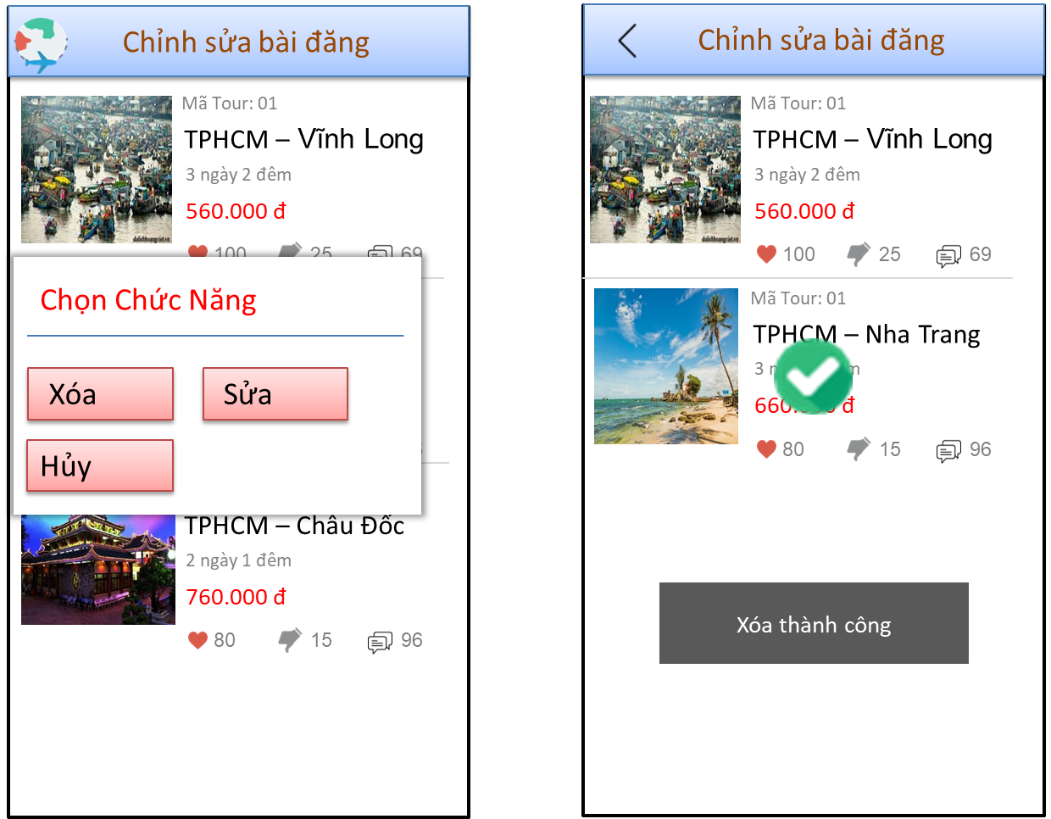

*Image15: Clear tour screen in post editing page*

### Functional Requirements

|  |  |  |  |
| --- | --- | --- | --- |
| Item | Description | Action | Response |
| Clear tour screen in post editing page | Include:   * 1 list view * Image * 3 button | N/A | N/A |
| List view | Show tour pictures, tour code, price, time corresponding | N/A | N/A |
| Image | Hình ảnh hiển thị cho phép Hãng du lịch “xóa” hay “ Sửa “ tour khi ấn đè vào Hình ảnh của tour The image displayed allows the travel agency to "delete" or "edit" the tour when pressed. | hold | Select "Delete" and "Cancel" |
| Button “Delete” | The command for permission to delete the tour from list | Click | Announcement and re-update tour list |
| Button “Cancel” | Allows the Travel Operator to cancel the selected operation | Click | Go to previous page |
| Button “Edit” | Allows the tour company to edit the tour | Click | Go to tour editing screen |
| Delete successfully | Notifications and icons  after a Delete successfully | N/A | N/A |

## **Feature/Component #14: Edit tour**

### User Interfaces

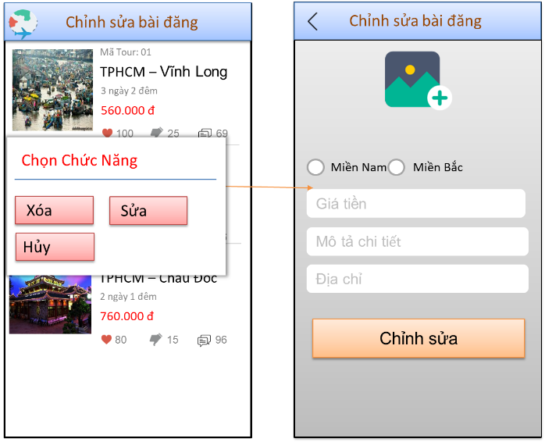

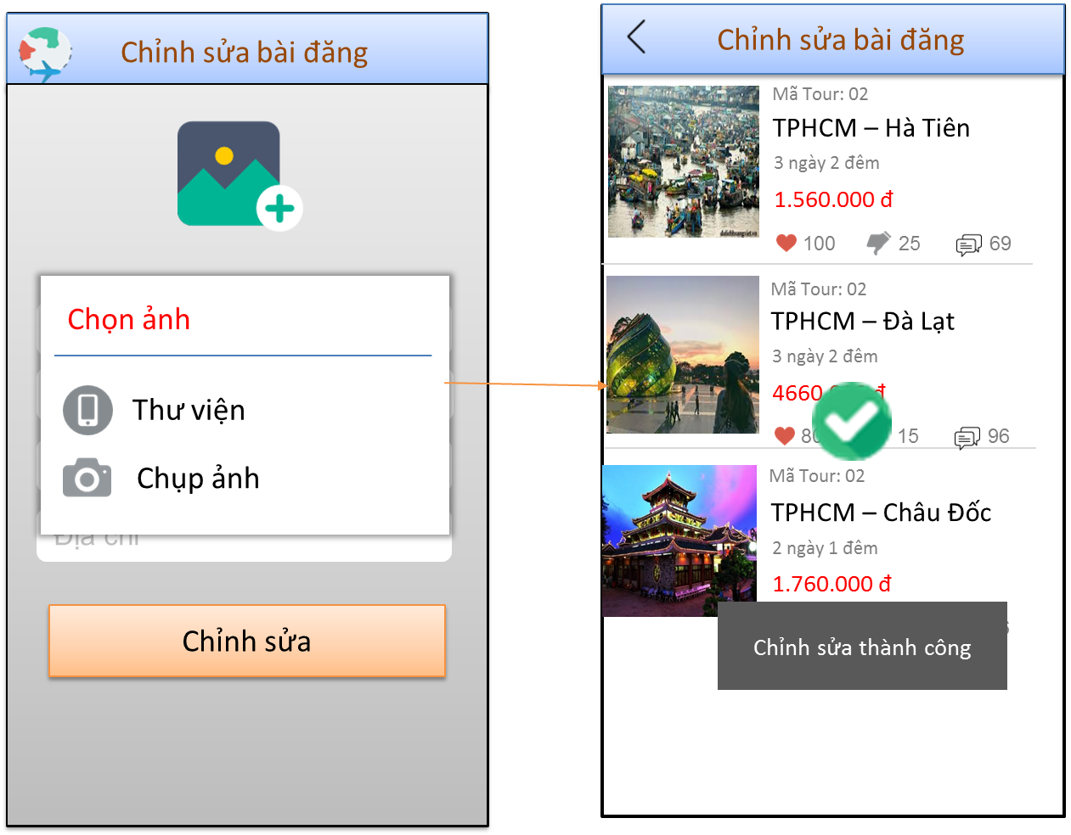

*Image16 : Edit Tour page in Edit post page*

### Functional Requirements

|  |  |  |  |
| --- | --- | --- | --- |
| Item | Description | Action | Response |
| Edit Tour page in Edit post page | Include:   * 1 list view * Image * 3 button | N/A | N/A |
| List view | Show tour pictures, tour code, price, time corresponding | N/A | N/A |
| Image | Hình ảnh hiển thị cho phép Hãng du lịch “xóa” hay “ Sửa “ tour khi ấn đè vào Hình ảnh của tour The image displayed allows the travel agency to "delete" or "edit" the tour when pressed. | hold | Select "Delete" and "Cancel" |
| Button “Delete” | The command for permission to delete the tour from list | Click | Announcement and re-update tour list |
| Button “Cancel” | Allows the Travel Operator to cancel the selected operation | Click | Go to previous page |
| Button “Edit” | Allows the tour company to edit the tour | Click | Go to tour editing screen |
| Icon | Choose a photo for the article by taking a photo or taking a photo. | Click | Updated photos on the new tour |
| Text box “ price ” | Edit Value for the tour | N/A | N/A |
| Text box “ Detailed tour details ” | Edit to more detailed calendar, specific schedule for the tour | N/A | N/A |
| Text box “ address” | Edit the travel agency to record the tour's location | N/A | N/A |
| Check box | Chọn “ domain ” | Click | Choose 1 from 2 regions: "Southern" or "Northern" |
| Button “ edit tour” | Once filled the tour information | Click | Thông bá chỉnh sửa thành công và cập nhật danh sách tour du lịch |
| edit success | Notifications and icons  after a successful edit | N/A | N/A |
|  |  |  |  |
|  |  |  |  |
|  |  |  |  |
|  |  |  |  |
|  |  |  |  |
|  |  |  |  |
|  |  |  |  |

## **Feature/Component #15: List of tour companies**

### User Interfaces

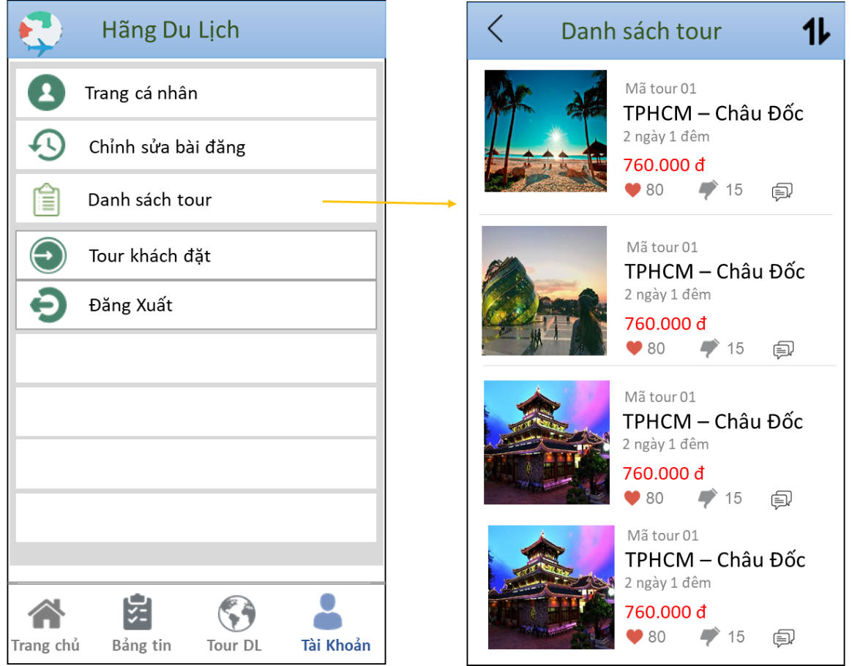

*Image17 : List of tour companies*

### Functional Requirements

|  |  |  |  |
| --- | --- | --- | --- |
| Item | Description | Action | Response |
| List of tour companies | Include:   * list view | N/A | N/A |
| List view | Show all information related to the tour | N/A | N/A |
| Icon | Arrange tours at a reduced or incremental rate | Click | Display results sorted by decreasing or increasing price. |
| Icon | Go to the previous page | Click | Go to the previous screen |

## **Feature/Component #16: Tour guests booked**

### User Interfaces

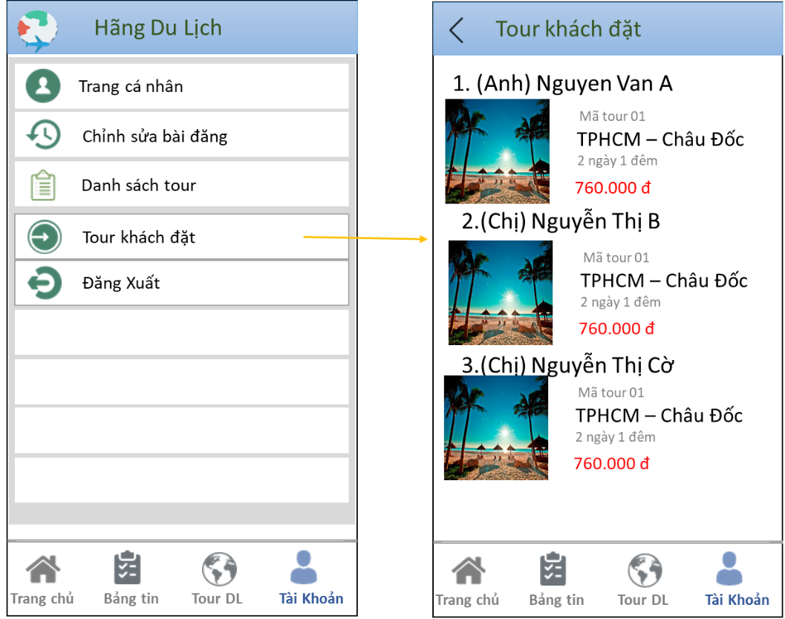

*Image18 : Tour guests booked*

### Functional Requirements

|  |  |  |  |
| --- | --- | --- | --- |
| Tour guests booked | Description | Action | Response |
| Tour guests booked | Include:   * list view | N/A | N/A |
| List view | Show detailed information about Tourists including (tour name, time, location, schedule) | N/A | N/A |
| Icon | Go to the previous page | Click | Go to the previous screen |

***---------- End of Document ----------***